**DAILY ONLINE ACTIVITIES SUMMARY**

|  |  |  |  |  |  |  |  |  |
| --- | --- | --- | --- | --- | --- | --- | --- | --- |
| **Date:** | **3/06/2020** | | | | | **Name:** | **SPOORTI S DAROJI** | |
| **Sem & Sec** | **4th SEM. & ‘B’ SEC.** | | | | | **USN:** | **4AL18CS088** | |
| **Online Test Summary** | | | | | | | | |
| **Subject** | | **OBJECT ORIENTED CONCEPTS** | | | | | | |
| **Max. Marks** | | **30** | | **Score** | | | **17** | |
| **Certification Course Summary** | | | | | | | | |
| **Course** | **Intro to Django for Web development** | | | | | | | |
| **Certificate Provider** | | | **Udemy** | | **Duration** | | | **3 Hrs.** |
| **Coding Challenges** | | | | | | | | |
| **Problem Statement 1: Write a Java program to find Last Digit of a^b (a to the power b) for Large Numbers.**  **Problem Statement2: Write a code segment in java to swap two numbers using call by object reference.**  **Problem Statement3:Write a function that takes a two-digit number and determines if it's the largest of two possible digit swaps.** | | | | | | | | |
| **Status: Executed.** | | | | | | | | |
| **Uploaded the report in Github** | | | | | **Yes** | | | |
| **If yes Repository name** | | | | | [alvas-education-foundation](https://github.com/alvas-education-foundation)/[spoorti_daroji](https://github.com/alvas-education-foundation/spoorti_daroji) [spoorti_daroji](https://github.com/alvas-education-foundation/spoorti_daroji)/coding_solutions/ | | | |
| **Uploaded the report in slack** | | | | | **Yes** | | | |

**Online Test Summary: 18CS45 test was scheduled from 9:30 am t0 10:00am .The portion for the IA was 2nd and 3rd module. There were 30 questions and the time assigned was 45 minutes. The questions were to predict the output of the given program.**

**Online Certification course Summary:**

**In today’s session I learnt about the Basic python**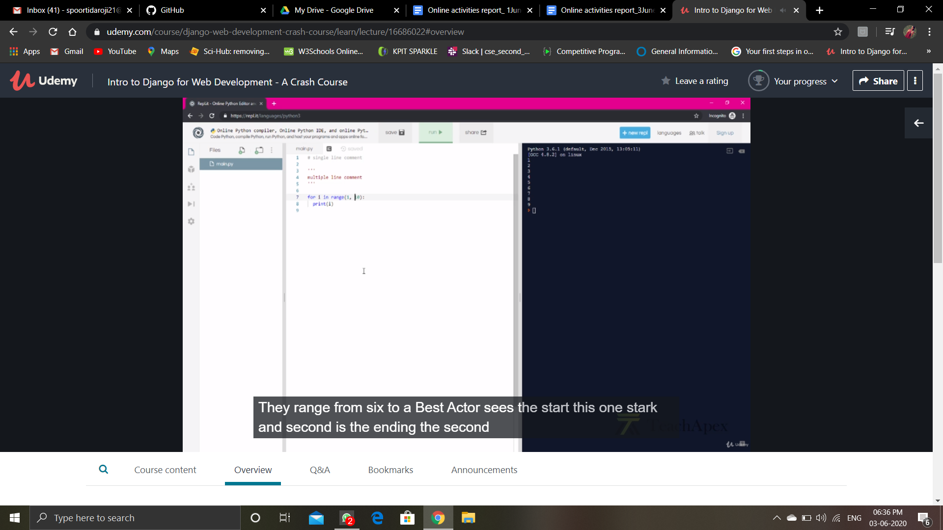

**Online Coding Summary: Today I received one program from prof. Shilpa CSE Dept, the other from Prof. Reena Lobo CSE Dept, and Prof.Vasudev CSE Dept. The program is mentioned above in the coding challenges(pg.01). I have also uploaded it to my Github repository.**

**The program is mentioned above in the coding challenges.I have written a program and uploaded it to my Github repository, as shown in the below.**



